PERSONAL INFORMATION | Rohmat Syahru Romadlon
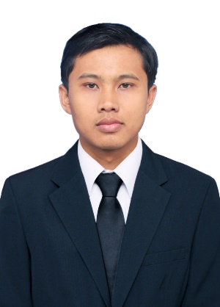 | Home town:  Purwokerto, Central Java  Current address:  Khartoum, Sudan
 | - +249 115 xxx xxx
 | rohmatsyahru@gmail.com
 | www.redhatblog.com
 | Skype xxxxxx
 | Sex Male | Date of birth 25/01/1992 | Nationality Indonesian

JOB APPLIED FOR | PRODUCTION ENGINEER (for example)

WORK EXPERIENCE

Mar 2017 – now | Logistic Supervisor  Sawabash Instant Noodle Factory – Indomie Sudan  - Jelaskan tentang pencapaian yang sudah dilakukan selama bekerja.  Misal: Membuat analisis harga bahan pokok yang sebelumnya belum pernah dibuat  - xxx  - xxx  Business or sector Instant Noodle Factory
Jan 2015 – Feb 2017 | Raw Material and Production Planner  Salim Wazaran Abu Alata – Indomie Egypt  - Menurunkan level stok raw material dari yang sebelumnya 90 hari stok menjadi 45 hari. Dengan pencapaian ini, perusahaan diuntungkan karena menghemat biaya sewa gudang, nilai inventory, biaya pallet, dll senilai total 15,000 USD.  - xxx  Business or sector Instant Noodle Factory
EDUCATION AND TRAINING | Bachelor’s degree, Industrial Engineering  at Yogyakarta University 2008-2013  Grade 3.64 out of 4.00  Specialized in production planning control, production system, supply chain management

PERSONAL SKILLS | Blogging and content creator

Mother tongue(s) | Bahasa Indonesia
Other language(s) | UNDERSTANDING |  | SPEAKING |  | WRITING
 | Listening | Reading | Spoken interaction | Spoken production
ENGLISH | Proficient user (C1) | Proficient user (C1) | Proficient user (C1) | Proficient user (C1) | Proficient user (C1)
ARABIC | Basic user (A2) | Basic user (A2) | Basic user (A2) | Basic user (A2) | Basic user (A2)
Levels: A1/A2: Basic user - B1/B2: Independent user - C1/C2 Proficient user
Common European Framework of Reference for Languages

Communication skills | - Share your communication skill here. You can ask to your colleague about your skill  - xxx  - xxx

Organisational / managerial skills | - Share your managerial skill here. You can ask about your strong and weakness from your colleague  - xxx

Job-related skills | - For example, you are expert in Microsoft Excel, PHP programming, etc.  - xxx

Digital competence | SELF-ASSESSMENT
 | Information processing | Communication | Content creation | Safety | Problem solving
 | Independent user | Independent user | Basic user | Basic user | Basic user
Levels: Basic user - Independent user - Proficient user
Digital competences - Self-assessment grid
- For example, you are good in Excel, PowerPoint, and photo/video editing. Share here
- xxx

Other skills | - Writing a blog  - xxx  - xxx

Driving licence | Car, motor cycle, etc.

ADDITIONAL INFORMATION

Seminars  Honours and awards  Certifications | - Training: Production Planning and Inventory Control (PPIC), Yogyakarta-Indonesia, 2011  - International Seminar of Supply Chain Management, xxx, 2012  - xxx  - xxx

Hobbies and Interest | Hiking  - Mount Sinai (2,285 m, Egypt on September 2016)  - Mount Slamet  - Mount Merbabu  Running  - Cairo Half Marathon 21K (Egypt, 2016)  - Alexandria 10K Run (Egypt, 2015)  - Indonesia Anniversary Run 2014

Annexes | - copies of degrees and qualifications;

